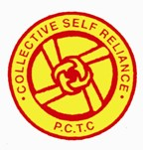
.
Community Based Rehabilitation Program for People with Disability
It has been another good year for the PCTC Rehabilitation Team, thanks to the continued support of staff, children, parents and donors. Most of our goals set for 2010 - 2011 have been successfully achieved.

I. Early Detection activity:
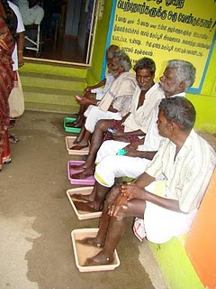
Unfortunately, due to a lack of support from the Nutrition workers, we were unable to carry out this activity beyond October. Between April and October we registered around 76 pregnant women as “High Risk Mothers” (women who are more likely to give birth to children with disabilities), 56 of whom were screened and given proper counseling and support. We were unable to prevent two miscarriages and one still birth. We are trying to find a way out to get regular support for our early detection activity.

II. Early Intervention activity:
After birth, the development of the children born to the High Risk Mothers was monitored for one month. Those who showed signs of delayed development were invited to attend our Early Intervention clinics in the Kariyandal and Nookkambadi centers. In all of the 25 children who attended, we observed remarkable improvements in the following areas:
General health and seizers (fits)
Physical development
Cognitive development (more emphasis will be placed on this in the coming months)
The attitude of the parents
The ability of the parents to handle their children effectively (carrying the children safely etc.)
We provided each child with the specific Therapeutic Intervention and Physical Development Aids
Self care training cum demonstration for leprosy cured persons at the primary health center- to sensitize them to use the services at the Primary health center
(seating devices and walkers) they required.

III. Parent Training activity:
The aim of this activity is to teach parents how to care for their disabled children effectively. At the beginning of the year we devised a strategy for how best to support each child and grouped them according to their needs. At the beginning of the year 109 children were involved in this activity, and 12 more were identified and integrated later. For various reasons, a total of 21 children dropped out of the project before the end of the year. The Parent Training Activity focused in these aspects:

- Therapeutic intervention - 33 children involved
- General health - 109 children involved
- Physical Development Aids – 16 children involved
- Functional Literacy - 19 children involved
- Daily Living Skills – 21 children involved
- Pre - Vocational Skills – 3 children involved
- Addressing behavioral issues – 5 children involved
- Communication Skills – 24 children involved
- Support for disabled children who attend normal schools – 24 children involved
- Speech Therapy - 6 children involved
- Training and support for parents of particularly “difficult” children – 15 children involved

This year, a total of 3 families finished the Parent Training Program (due to the children turning 18), but PCTC continues to support them.

IV. Day Care Center:
One of the principle activities in our Rehabilitation program is the Day Care Center (DCC), which provides motivation and support for children in the Early Intervention and Parent Training activities in both our Kariyandal and Nookkambadi centers. At the beginning of the year we had 11 children in the Kariyandal center, which increased to 19. This was achieved by extending transport facilities to more remote areas, and support from parents (financial assistance and positive cooperation). At Nookkambadi, we began with 19 children, which dropped to 8 in January due to a transport problem (local schoolchildren and their parents objected to some of our children using school transport). Again we extended transport facilities to remote villages, and finished the year with 15 children.

The day care centers are run with one member of staff for every five students, and the timings are 8 am to 5pm, Monday to Friday. The activities include:
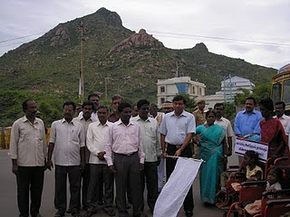
- Prayer
- Breathing exercises
- SPL education
- Physical therapy skills
- ADLS Training
- Lunch
- Group Education (songs, stories, plays)
- SPL Education
- Play
- ADLS Training
- Physical Therapy - 14 children involved
- SPL education – 34 children involved
- ADLS Training – 18 children involved
Flagging of Rally by the District Collector- to sensitize people on integrated education for the children with special needs
- Communication Skills
- Developmental aids – 8 children involved
- Medical treatment – 19 children involved
- Seizure treatment – 7 children involved
- Extra training for specific behavioral issues – 5 children involved
- Treatment for drooling – 3 children involved

Every day we provide children with supplement food to help them gain weight, and monthly home visits ensure that adequate care is being provided by the parents. Every month we organize a meeting and training session for the parents involved.

Several of our children participated in World Differently Able Day in early December, performing a dance which they had been working on. On the 31st of December we celebrated Makkal Thiruvizha: several children performed a dance, sports activities were provided for 102 children and gifts (including items like bed sheets) were given to children and parents.

Over the course of the year many volunteers from various countries have spent time at PCTC, and they have contributed noticeably to the progress of our children.

V. Vocational Training:
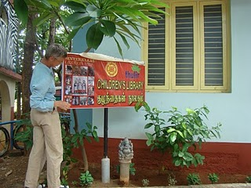
Even the most talented differently-able children are struggling once they leave education, due to prejudices and lack of awareness among parents and communities. To combat this, we have been running vocational training activities in both of our centers. A total of 20 children have been involved in this activity, and the activities include:

- Sewing and tailoring – 9 children involved
- Manure composting - 6 children involved
- Center maintenance – 6 children involved
- Gardening - 9 children involved
- Envelope making - 2 children involved
- Manufacture of “plastic wire bags” food bags - 2 children involved

Additional activities include:
- Functional literacy
- Daily living skills
Inauguration of Children’s library- at Kariyandal campus by the Donor- Marie jose wouters from the Netherlands
- Life education skills
- Leisure activities

The parents play an active role in identifying a suitable trade for their children to be trained in. Monthly meetings are held
with parents to evaluate the progress of their children.

PCTC has links with several local employers, and we hope to send
many of our children to them once they finish their Training.

VI. Staff Training:
- The roles and responsibilities of each member of staff are clarified and discussed regularly.
- Every month, the achievements of each member of staff are discussed and compared to their initial targets.
- Weekly and monthly review sessions are held for all staff.
- The third Saturday of every month is reserved for staff training in which each member of staff provides a case study of one child; presentations are made; teaching resources are provided and lesson plans prepared.

CBR Activities:
- This year, we identified 31 PWD’s (person with disability) in the area.
- One welfare worker, who will carry out CBR work, has been provided in each of the 47 Panchayats.
- Rehabilitation camps have been held in 22 of the village Panchayats. These camps included meetings, reviews, assessments of a total of 636 PWD’s out of which 393 persons received various kinds of rehabilitation interventions from PCTC as well as from government sources.
- PCTC has collaborated with the Leprosy Mission Trust India to identify and support leprosy affected persons in the area.
- Awareness has been raised of the local Primary Health Center and the benefits that it can offer to people in the area.
- Ulcer treatment has been provided for the leprosy affected persons and Micro Cellular rubber sandals were provided to them.
- An article was published in “The Hindu” newspaper about the present state of Leprosy affected persons in the block which has shown the neglect status of these people both by the families and the public health system.
- School visits have been made, providing academic SPL education to children in the 6 to14 age range.
- PCTC organized a National Identity Card camp, which provided 6 differently-able children with ID cards.
- Another camp was organized to provide children with developmental aids: a total of 53 children benefited.
- 74 were encouraged to apply for government educational grants, of which 61 were successful.
- Group Parent Training was organized in the Vallivagai and Kamalaputhur panchayats: 12 parents unable to attend regular meetings at PCTC benefited from this program .
- Applications for free bus passes were sent to the government: 43 PWD’s benefited. Many of the beneficiaries use their bus passes to travel to work and to PCTC’s vocational unit and DCC
- 1 hearing aid was applied for and received.
- 3 hand operated tricycles were provided to local people.

Thulir Program:

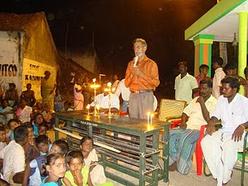
Throughout the year 8 centers were functioning in Mangalam, Devanampattu, Narthampoondi, Vedanthavadi ( 1&2), Kuniyanthal, Porkunam and Kothanthavadi. Totally 240 school children were enrolled in these centers. Every evening these children met in the designated place for two hours gave them the opportunity to do their academic work as well get inputs in life oriented skills and extra curricular activities, which they have exhibited during the people’s festival 2010. Children also had inputs on Theatre skills, Environment, identification and the uses of herbs, Social integration of children with disability and career guidance.
Inauguration of new Thulir center at Kunniyandal Village

Makkal Thiruvizha: 2010 (People’s Festival)
Makkal Thiruvizha 2010 was celebrated with usual fun and participation. For the first time the festival was hosted by The Panchayat level Federation of Devanampattu (which consists of 27 self help groups). More than 5000 people participated in the day long program. The day was filled with competitions, games, cultural programs, exhibition and talent show program by Thulir children. It always gave the opportunity for the children with special needs to come out of their house, which paves the way for social Integration.
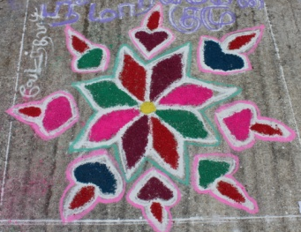
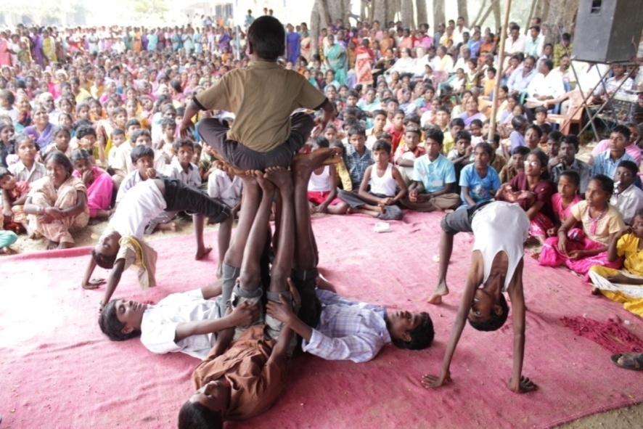

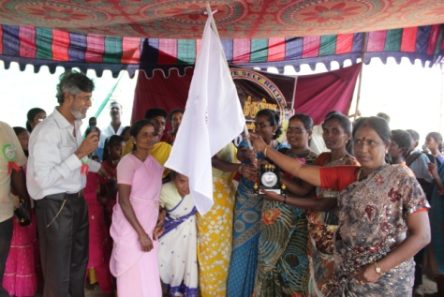
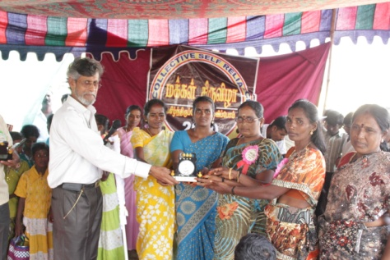
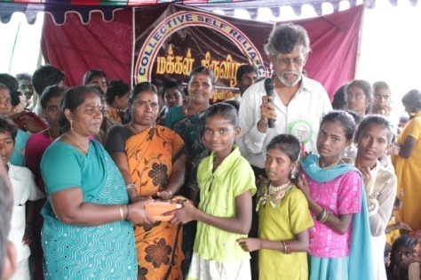
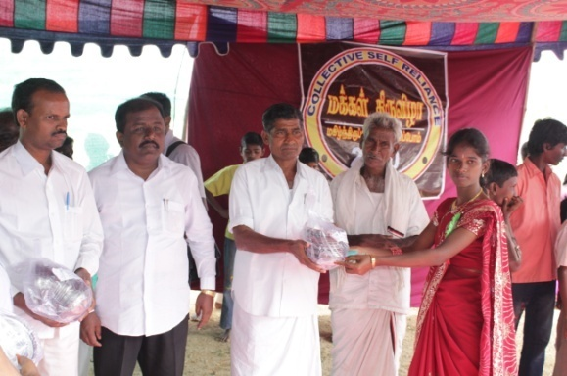
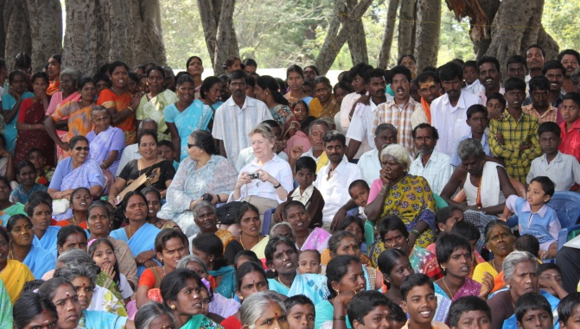
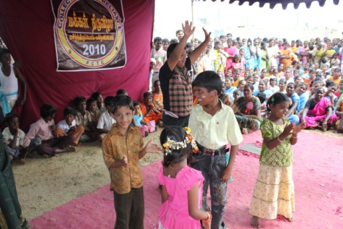
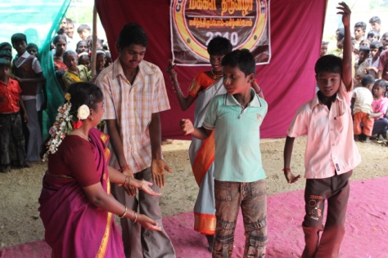
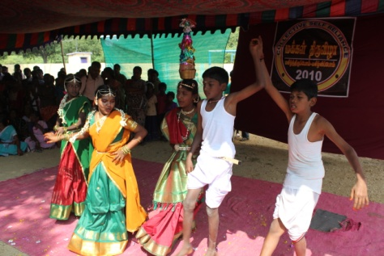

Our supporters:

PCTC has been able to carry on its activities for the last 20 years without any interruption is because of its supporters- well wishers, donors and volunteers. We are fortunate that every one of our donors share the same ideology, which makes things easy for us to sustain the program.
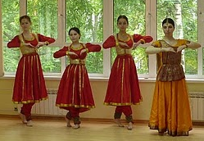
The volunteers who come to PCTC, not only contribute during their stay, but also sustain their relation with the organization and closely associate with the activities in whatever way possible. Nathalie continued to work in the farm till February 2010, who was placed as a volunteers through SCD, France. Totally 9 volunteers were at PCTC during the course of the year and got involved in the various programs of PCTC. Niall Williams who was in 2000 at PCTC is working in Moscow in an International school. during the celebration of India week in his school ,
Cultural program by students During India week celebration in Moscow – English International School
he raised donations to support PCTC.

PCTC –Balance Sheet for the year 2010-2011
Liabilities | 2010-2011 | Assets | 2010-2011
Capital fund | 1,37,75,070.13 | Fixed Assets | 1,16,35,784.00
Project Fund | 24,27,173.11 | Corpus and reserve funds (Investments) | 1,52,10,000.00
Corpus and reserve funds | 1,52,10,000.00 | Cash and Bank Balance | 45,66,459.24
Total | 3,14,12,243.24 | Total | 3,14,12,243.24
PCTC- Receipts and Payments for the year 2010-2011
Receipts |  | % | Payments |  | %
To Opening Balance | 32,23,446.98 | 32.7 | BY CORE PROG. EXPEND. | 9,05,320.00 | 9.2
To Grants Received | 15,35,935.51 | 15.6 | BY REHABILITATION | 10,69,057.00 | 10.8
To Other Receipts | 51,01,496.27 | 51.7 | BY CHILD LINE EXPENSES | 8,055.00 | 0.1
 |  |  | BY WOMEN DEVELOPMENT | 1,58,016.00 | 1.6
 |  |  | BY FARM | 1,66,258.00 | 1.7
 |  |  | BY COMPUTER SCHOOL | 39,841.00 | 0.4
 |  |  | BY REPAIRS AND MAINTEN. | 73,897.00 | 0.7
 |  |  | BY PROG.MAINTENANCE | 3,58,483.52. | 3.6
 |  |  | BY ACQUISITION OF ASSETS | 25,15,492.00 | 25.5
 |  |  | BY CLOSING BALANCE | 45,66,459.24 | 46.3
Total | 98,60,878.76 | 100 | Total | 98,60,878.76 | 100

PEOPLE’S CRAFT TRAINING CENTER(PCTC), KARIYANDAL, VIA-NAYUDUMANGALAM-606802.,
Tamilnadu, South India. Ph: +91 4175 246464; Fax: + 91 4175 246215.;
Email: pctcxavi@gmail.com; Website: www.pctcability.org.; Blog: pctcnews.blogspot.com

Fund raising program for PCTC in English International School-Moscow- Organised by Niall Williams.

